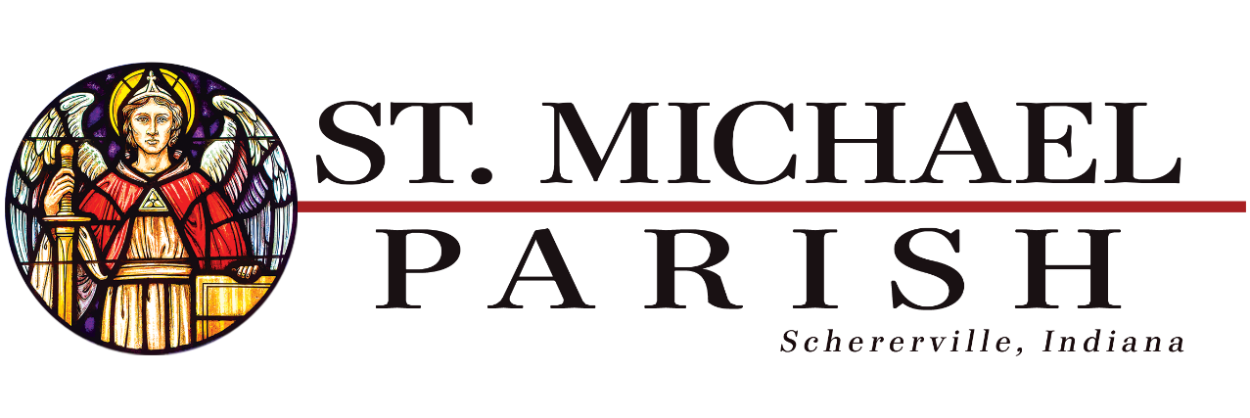

Adult Confirmation

Confirmation enriches the baptized with the strength of the Holy Spirit so that they can better witness to Christ in word and deed
CCC, no. 1285

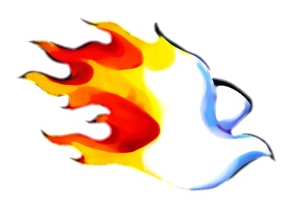CONFIRMATION FOR ADULTS – 2023

For the Sacrament of Confirmation, the baptized are more perfectly bound to the Church and are enriched with a special strength of the Holy Spirit.

If you are a Baptized Catholic, 18 or older, out of high school and you have also received First Communion and First Reconciliation, but for whatever reason, you have not been confirmed, then this may be for you.

Preparation for Adult Confirmation will be offered on Tuesday: *MUST Attend 2 classes
- May 9- 6:00 PM- 8:00 PM
- May 16- 6:00 PM- 8:00 PM

WHERE: St. Michael Parish Hall/ West Meeting Room
1 W Wilhelm Street, Schererville, IN 46375
WHO MAY ATTEND: A Candidate Must:
  - Be 18 years old AND out of high school
  - Have been baptized in the Catholic Church
  - Provide Baptismal Certificate
  - Provide proof of Reconciliation & Holy Communion

CONFIRMATION MASS: Sunday, May 28, 2023 @ TBD

Location – Cathedral of the Holy Angels 640 Tyler Street Gary, 46402

ADULT CONFIRMATION REGISTRATION FORM

REGISTRATION FORM- 2023 SPRING ADULT CONFIRMATION
*PLEASE PRINT
Name_________________________________________________________________________
Address_______________________________________________________________________
City/ State ____________________________________________ Zip_____________________________
Phone_________________________________________
E-mail_________________________________________
Parish Name/Town____________________________________________________________________
Date of Birth__________________________________________________ Age__________________
*Priest/Staff Signature from current/home parish
___________________________________________________ Date: __________________________

Please bring a copy of your baptismal certificate on the first night or email to:

Via email: khoogeveen@stmichaelparish.life or call 219-322-3077

